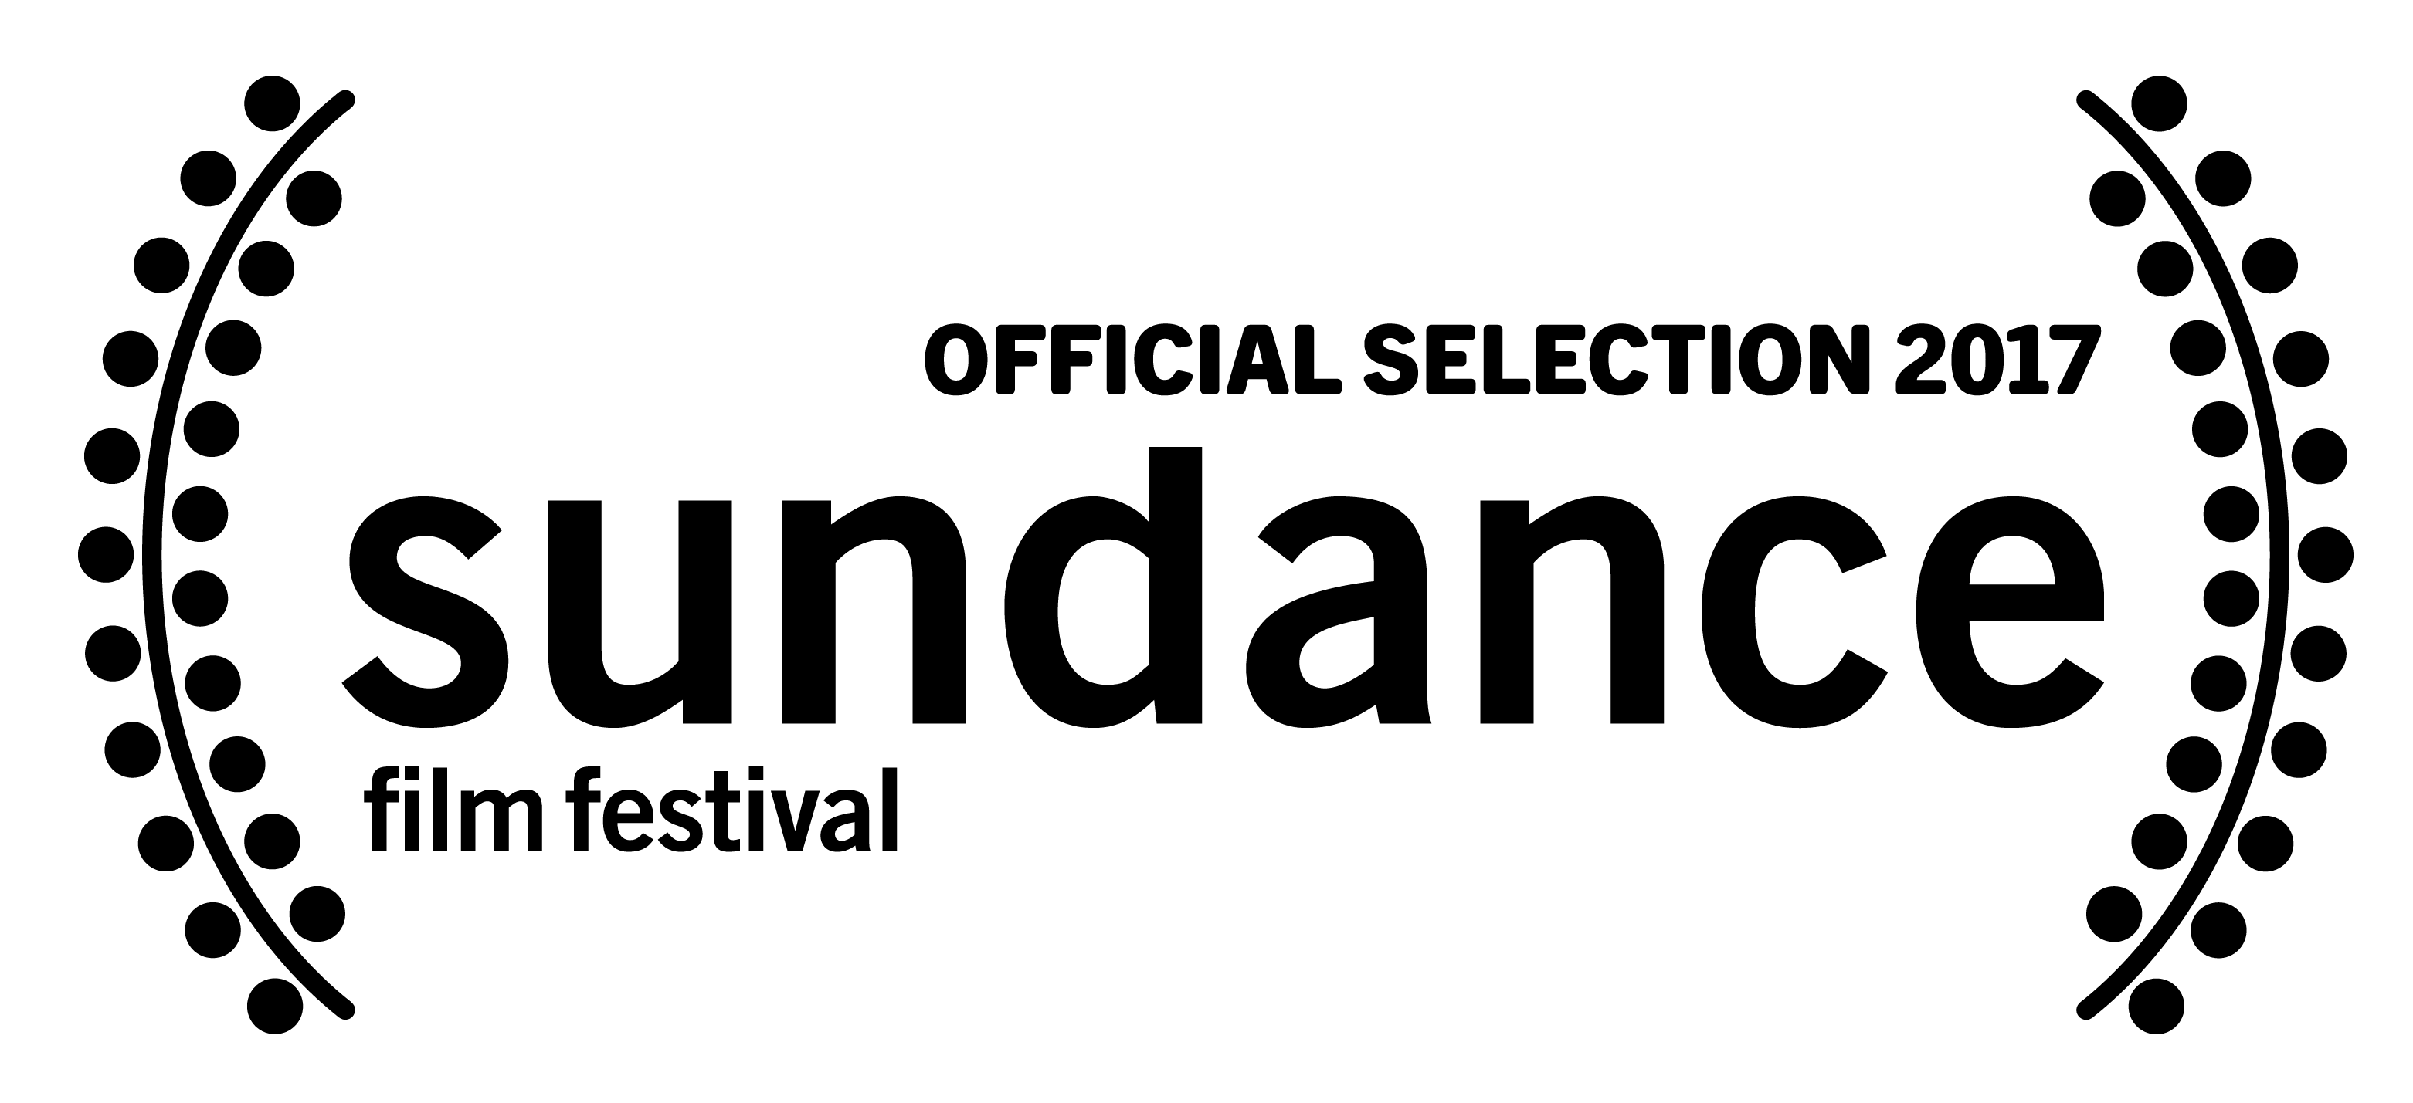

MOTHERLAND
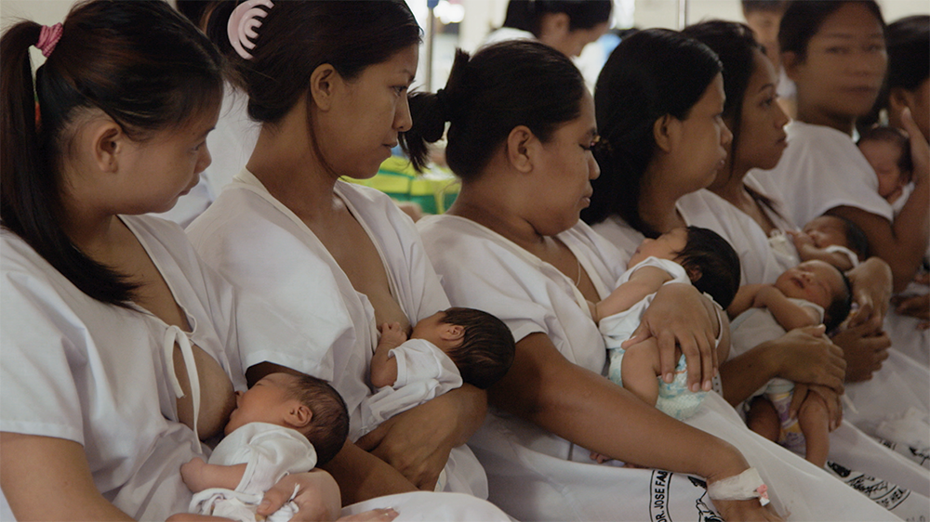
A film by RAMONA S. DIAZ

(BAYAND INA MO)
94 Minutes | In Tagalog with English Subtitles

Press Contact:
Yung Kha
19-23 Ironmonger Row, London EC1V 3QN, UK | Tel: +44(0)20 7253 6244
yung@dogwoof.com
LOGLINE

Taking us into the heart of the planet’s busiest maternity hospital, this cinematic experience drops the viewer like an unseen outsider into the hospital’s stream of activity. At first, the subjects are strangers. But, as the film continues, it becomes absorbingly intimate, rendering increasingly familiar.

SYNOPSIS

MOTHERLAND takes us into the heart of the planet’s busiest maternity hospital in one of the world’s poorest and most populous countries: the Philippines. The film’s viewer, like an unseen outsider dropped unobtrusively into the hospital’s stream of activity, passes through hallways, enters rooms and listens in on conversations. At first, the surrounding people are strangers. But as the film continues, it's absorbingly intimate, rendering the women at the heart of the story increasingly familiar. Three women—Lea, Aira and Lerma—emerge to share their stories with other mothers, their families, doctors, and social workers. While each of them faces daunting odds at home, their optimism, honesty, and humor suggest a strength that they will certainly have to summon in the years ahead.

STATISTICS

- Population of the Philippines is 102,575,650 (as of Sunday, September 18, 2016), based on the latest United Nations estimates.
- 12th most populous country in the world, equivalent to 1.37% of the total world population.
- The landmass of the Philippines is equivalent to the state of Arizona.
- Growth Rate is 1.72% year in 2015, around 2 million births per year
- Life expectancy is 68.55 years.
- More than 86% of the country’s population is Catholic.
- Birth Rate: 24/1000 population 2014
- Maternal Mortality rate: 99/100,000 live births (2010)
- Infant Mortality rate: 18/1000 live births (2014) 1.8%
- Industrialized nations: average of 2/1000 .2%
- Poverty line: 27% live below poverty line 2009
- Unemployment rate: 7% 2013
- Dr. Jose Fabella Memorial Hospital – 100 in a 24-hour period
- Winnie Palmer Hospital in Florida 54 deliveries in one day – 11 stories high
- National Maternity Hospital in Dublin averages (busiest and largest in Europe) – around 25 babies day or 9,000/annual

DIRECTOR’S STATEMENT- Ramona S. Diaz

I started developing a film about reproductive rights and reproductive justice back in 2011. Initially I had wanted to follow the social and political drama swirling around the passage of the Reproductive Health Bill. As originally conceived, the film was going to follow the bill as it went through the legislative process. While researching the film, I visited the Dr. Jose Fabella Memorial Hospital, the busiest maternity ward on the planet; it averages 60 births a day—and at its peak, as many as 100 babies within a 24-hour period. Fabella is the final safety net for very poor pregnant women, most of whom cannot afford either contraception or the $60 delivery fee. The images I saw at the hospital - the nurses who did their best to tame the noisy chaos of Emergency Room arrivals, the crowded corridors, the premature births and cramped recovery rooms with double occupancy of single beds – gripped me and wouldn’t let go. It was soon evident that the story I was looking for, a story about reproductive justice and maternal and women’s rights, unfolded within the hospital walls.

As I shifted the gaze of my camera, I also decided on an exclusively cinéma vérité approach to capture the daily rhythms of the hospital. Day in, day out, the routines at Fabella repeat themselves. Pregnant women arrive, mothers with babies leave. Outside on the street, visitors line up. Inside the ward, pregnant women, fanning themselves because there is no air-conditioning, await the signs of labor that will advance them to the delivery room and eventually the delivery staff’s cry: “Baby out!” As in most immersive experiences, once the routine washes over you, the real story emerges. And the story I found was one of community and humor. The women talk unabashedly with each other about sex. A nurse counsels them on hygiene, speaking into a microphone like a stand-up comic, teasingly instructs them to bathe hidden body parts so their husbands and boyfriends will still want to have sex with them—and not chase after other women. They shared not only stories but also their bodies, literally – breastfeeding other women’s babies is not an uncommon sight. The narrative that emerges is a tableau of not only poverty, but also of warmth, generosity, and fortitude. The fleeting but profound relationships forged on those cramped beds are the emotional bedrock of the film.

The story that unfolds in Motherland, while taking place in the Philippines, is universal. The wondrous mystery of motherhood is apparent in every frame of the film, in the sweat and screams of a first-time mother in labor, in the peace of her newborn being placed at her swollen breast, in the awkward laughter as she flounders to diaper her squirming baby. The joy in Fabella is no different from the joys experienced by mothers worldwide. However, because this takes place in the Philippines, this film invites audiences to witness analogous situations from the starkly different perspective of a poor, densely populated, Catholic country.

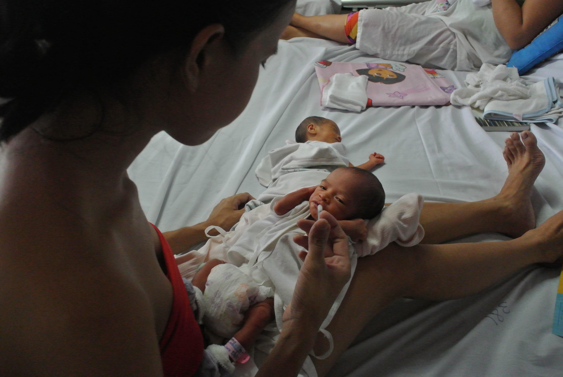

ABOUT THE FILMMAKERS

RAMONA S. DIAZ (Director, Producer, Writer, Co-Editor)
An award-winning Asian-American filmmaker best known for her compelling character-driven documentaries that combine a profound appreciation for cinematic aesthetics and potent storytelling. Her films, which include SPIRITS RISING, IMELDA, THE LEARNING, DON’T STOP BELIEVIN: EVERYMAN’S JOURNEY and MOTHERLAND, have demonstrated her ability to gain intimate access to the people she films—be they rock stars, first ladies, dissidents, teachers, or mothers—resulting in keenly observed moments and nuanced narratives that are unforgettable. While her stories focus on the Filipino and Filipino-American experience, Ramona’s films transcend their specificity and are universal in spirit. Her films have been broadcast on POV and Independent Lens and have screened and won awards at Sundance, Berlin, Tribeca, Silverdocs, IDFA, and many other top film festivals. She has received funding from ITVS, CAAM, Sundance Documentary Fund, MacArthur Foundation, Tribeca Institute, Catapult Film Fund, and Chicken &amp; Egg. Ramona has also served on numerous film festival juries and funding panels. Recently she was awarded the prestigious Guggenheim Fellowship and was inducted into the Academy of Motion Picture Arts Sciences. Ramona has been a film envoy for the American Film Showcase, a joint program of the U.S. Department of State and USC that brings American films to audiences worldwide. She has conducted master classes and production and post-production workshops all over the world, including in Iraq, Laos, Morocco, Qatar, Zimbabwe, Brazil, and throughout the United States.

REY CUERDO (Producer)
A Sony Pictures executive for 22 years, Rey began producing feature films as a hobby in 2002. He produced the drama SMALL VOICES, which won Best Film in all of The Philippines’ film industry awards, was the country’s official entry to the Oscar and Golden Globe awards, and became the first Filipino film to be distributed by a major Hollywood studio (Warner Bros). In 2008, Rey executive produced DIM SUM FUNERAL, an HBO Films comedy. He was an executive producer of the Filipino horror-comedy hit REMINGTON AND THE CURSE OF THE ZOMBADINGS in 2011, and secured U.S. and international distribution for it, as well as an English-language remake in development. In 2015, Rey produced TOTO, a festival award-winning Filipino American comedy. He helped produce MOTHERLAND, a Filipino documentary feature film which will premiere at the Sundance Film Festival 2017. At Sony, Rey is spearheading an effort to open local-language film markets in the Philippines and Indonesia.

NADIA HALLGREN (Director of Photgraphy)
Nadia is an award-winning filmmaker and cinematographer from the Bronx, New York. She is an alumna of International Center of Photography and was mentored by filmmaker Kirsten Johnson. Her Director of Photography credits include the Academy Award Nominated and Sundance grand jury prize winner TROUBLE THE WATER, CITIZEN KOCH, TRAPPED, TOUGH LOVE, WAR DON and THE NEW BLACK. Nadia has also contributed photography to feature Documentaries including FAHRENHEIT 9/11 SEARCHING FOR SUGARMAN, THE HUNTING GROUND, SUITED, SOUTHER RITES, and HOW TO DANCE IN OHIO. She has worked closely with top Documentary filmmakers including Michael Moore, Sharmeen Obaid-Chinoy, Morgan Spurlock, Joe Berlinger, Tia Lessin and Carl Deal. Nadia is a Cinereach fellow and recently co-directed a short film with Laura Poitras.

CLARISSA DE LOS REYES (Cinematographer)
Clarissa is a filmmaker born and raised in the Philippines who migrated to New York City where she attended NYU’s Tisch School of the Arts. Her short films have screened in many film festivals including Palm Springs, Busan, Fribourg, Vancouver International film festivals, American Cinematheque’s 8th Annual Focus on Female Directors etc. She collaborates extensively as a Director of Photography for award-winning narrative and documentary short and feature films and has worked in China, Taiwan, Philippines and the US. Her most recent work ALMOST SUNRISE by filmmaker Michael Collins is currently making its festival run and will be aired on PBS in 2017. She is currently developing her first narrative feature script film JOHNNY LOVES DOLORES with the New York Women in Film and Television “From Script to Pre-Production” Lab.

LEAH MARINO’S (Editor)
Leah’s home is in Austin, TX where she's edited documentaries for 20 years. Recent work includes Deborah Esquenazi's SOUTHWEST OF SALEM (premiered Tribeca, 2016) about four young lesbian women who spent 15 years in prison wrongly accused of sex crimes against two little girls. Previously she worked on Robert Byington’s 7 CHINESE BROTHERS, starring Jason Schwartzman, her first venture into fiction film editing (premiered SXSW, 2015). Marino edited ABOVE ALL ELSE, about one man’s struggle against the Keystone XL pipeline (premiered SXSW 2014). In 2013, she completed Ramona Diaz’s DON’T STOP BELIEVIN: EVERYMAN’S JOURNEY. Previous editing projects with Diaz include THE LEARNING and IMELDA. Her work includes projects on race car drivers, super fund sites, revolutions, and civil rights movements. She enjoys helping each film to realize it’s unique story and purpose in the larger world.

CREDITS

A Film by Ramona S. Diaz
A CINEDIAZ PRODUCTION
IN ASSOCIATION WITH KIDLAT ENTERTAINMENT

EDITED BY Leah Marino

CINEMATOGRAPHY BY Nadia Hallgren, Clarissa De Los Reyes

PRODUCED BY Ramona S. Diaz,Rey Cuerdo
EXECUTIVE PRODUCER Brillante Mendoza
WRITTEN & CO-EDITED BY Ramona S. Diaz
CO-PRODUCER Leah Marino

LINE PRODUCER Chris Rodriguez

LOCATION SOUND Mark Laccay

ASSISTANT CAMERA Jun Bual

WRITING CONSULTANT Julie Mackaman

DAILIES Digital Cave, Nick Kovacic, Matt Riggieri

COLORIST/ONLINE EDITOR Daniel Stuyck

DIALOGUE EDITOR/PRE-MIXER Miles Foster-Greenwood

SOUND EFFECTS EDITOR/DESIGNER Wayne Bell
RE-RECORDING MIXER Tom Hammond
POST PRODUCTION SOUND SERVICES Soundcrafter, Austin

SENIOR PRODUCER OF NATIONAL
PRODUCTIONS FOR ITVS Richard O’Connell
SUPERVISING PRODUCER FOR ITVS David Eisenberg
CONSULTING PRODUCER FOR ITVS N’Jeri Eaton

TITLE GRAPHICS Laurel Barickman, Recspec

FISCAL SPONSOR Women Make Movies
LEGAL COUNSEL Justine Jacob, Blyth, Lee & Associates
ACCOUNTING SERVICES Rita Brantner, Brantner & Associates

INSURANCE SERVICES Steve Thomas, Walterry Insurance Brokers, Charles Whelan Insurance Agency
GLOBAL SALES AGENTS, Dogwoof

THE FILMMAKER WISHES TO THANK THE PHILIPPINES’ DEPARTMENT OF HEALTH AND THE STAFF AND PATIENTS OF THE DR. JOSE FABELLA MEMORIAL HOSPITAL.
Lea Lumanog | Lerma Coronel | Aira Joy Jubilo

Dr. Ruben Flores | Dr. Esmeralda T. Ilem | Jhon Brayan Busalpa | Myriam Pelareja | Josephine Leybag | Elmer Bonto | Angel Joy Carandang | Jovelyn Razonable | Juanit Patron | Maricon Quintana | Mary Jane Ymane | Katrina Acorda | Edna Jimenea | Roselle Doroteo | April Pintuyan | Alvin Soner | Anne Michelle Medrano | Wilfredo Tabano | Jean Tabano | Catherine Palisoc | Mary San Jose | Merry Joy Antojado | Rogine Norombaba | Jemimah Taladro | Rialyn Rosario | Eyan Ariong | Gloria Moises | Jennifer Tumayong | Mary Jane Estrella | Monette Ang | Jane Ibanez | Anelyn Poras | Jeden Toboran | Nilda Rey | Dotty Baltazar | Juanita Patron | Christine Baldobino | Elisa Navarro | Jhun Michael Bagalay | Myra Clemente | Jacqueline Adorio | Laurie Negrana | Mel Torres | Norma Soriano | Mario Kabatongan
SPECIAL THANKS
Suzie Rueda | Dr. Enrique Ona | Andie Recto | Sabina Diaz-Rimal | Alexandra Lamb-Moran | Joanna Vasquez Arong | Anna Zosa | Rahdi Taylor | Cara Mertes | Kristin Feeley | Tabitha Jackson | Judith Helfand | Julie Parker Benello | Wendy Ettinger | Jenni Wolfson | Iyabo Boyd | Lisa Kleiner Chanoff | Bonni Cohen | Debbie Zimmerman | Barbara Ghammashi | Tracie Holder | Kristen M. Fitzpatrick | Laura Harrison | Ivana Folle | Alessandra Natale | Arielle Moreau | Valeria Soave | Milton Talbot | Alex Cantin | David Wilson | Paul Sturtz Pamela Cohn | Jed Dietz | Amy Johanson | Erica Ginsberg | Patrick Wright | Paul Flinton | Eliza Licht | Nikki Heyman | Niclole Tsien | Anna Godas | Vesna Cudic | Ana Vicente | Gemma Purkiss | Luke Brawley
EXECUTIVE PRODUCER FOR ITVS
Sally Jo Fifer

EXECUTIVE PRODUCERS FOR AMERICAN DOCUMENTARY | POV
Justine Nagan and Chris White

PRODUCTION FUNDING FOR MOTHERLAND WAS PROVIDED BY
Catapult Film Fund
Chicken and Egg Pictures

Sundance Institute Documentary Film Program
with support from Open Society Foundations
Ford Foundation JustFilms

With Additional support from
Women Make Movies’ Production Assistance Program
A Bogliasco Foundation Fellowship
The Independent Filmmaker Project

MOTHERLAND IS A CO-PRODUCTION OF
CINEDIAZ, INC.,
INDEPENDENT TELEVISION SERVICE (ITVS)
and AMERICAN DOCUMENTARY | POV,
with funding provided by CORPORATION FOR PUBLIC BROADCASTING (CPB)

TO SABINA SHEELA, FOR THE ENCHANTMENT

Motherland (Bayang Ina Mo) was produced by CineDiaz, Inc.
which is solely responsible for its content.

© 2017 CINEDIAZ, Inc. All Rights Reserved.

